Lab 3 report

Screenshot of all the circuits:

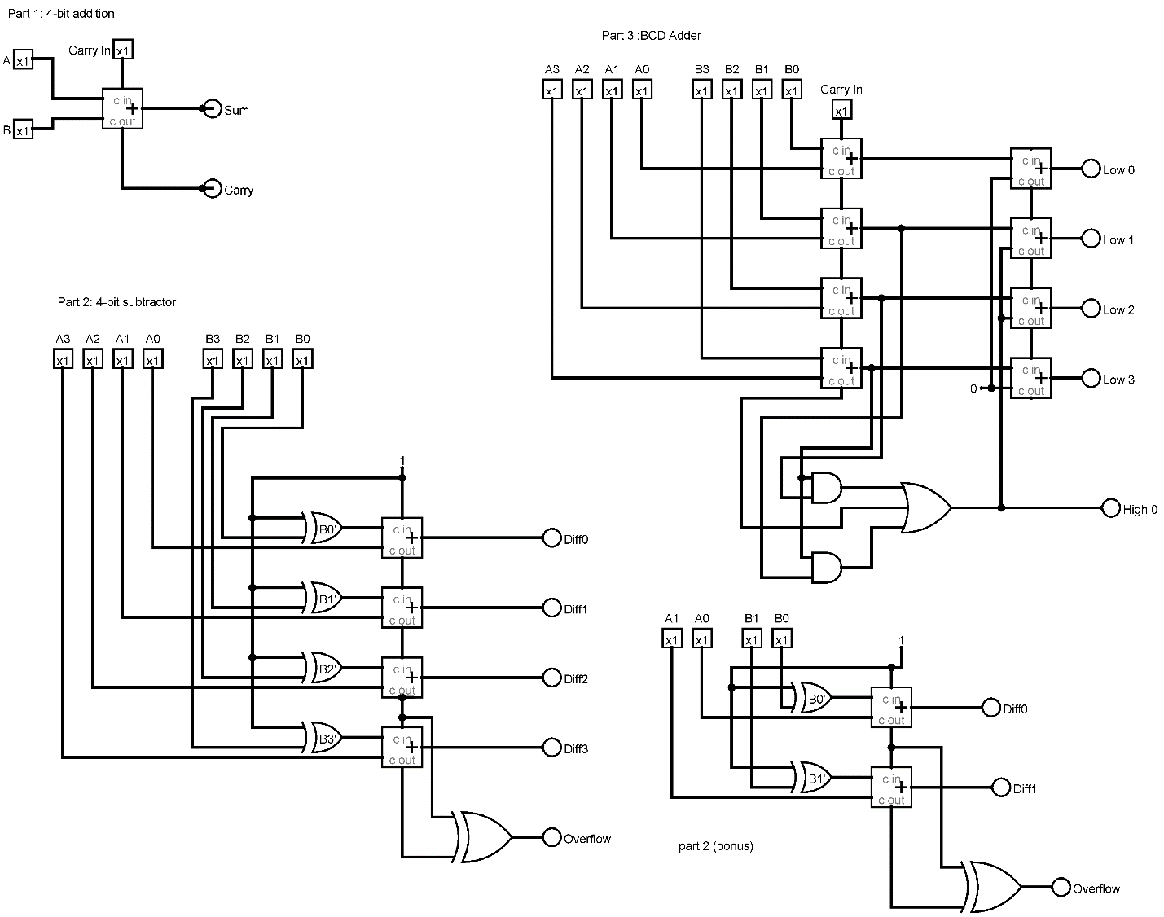

5.

1) For part 1 , A one data bit Adder is used. Three inputs pins , labelled A, B and Carry in is connected to the One bit Adder. Two LED Output , Sum and Carry is connected to the One bit adder as well. A and B inputs are connected on the Adder’s input pins, Carry in input is connected to the C in pin. The Sum LED is connected to the Sum pin in on the One bit Adder and the Carry Output is connected to the C out pin in on the One bit Adder. The functionality of the circuit is as follows, if the One bit inputs , A and B is supplied to the Adder, then depending on their values the Sum and Carry LEDs will light up, Carry in is set to 0. Example, if input A is set to 1 , and if input B is set to 1, the result of the addition will be an overflow therefore the Carry LED will light up, which will have a value of 1, and Sum will not light up, which will indicate that the value is 0. If input A is set to 1, and if input B is set to 0, the result of the addition of bits will be 1, and no overflow will occur, therefore, the Sum LED will light up and Carry LED will not light up. To Do a 4-bit addition, we will need 4 copies of this circuit, where the C out of each of the One bit Adders will connect to its adjacent One bit Adder’s C in pin. Inputs A0-A3 and B0-B3 will be connected to the One bit Adders. The Sum pins to be connected to The S0-S3 LED. A carry out LED Carry, will be connected to one end of the series of Adders, while on the other end of the Adder a Carry in is attached to C in pin of the other end of the series of Adders. If all the inputs , A0-A3 and B0-B3, are set to 1, if we add them up we will have a 1111 + 1111 = 1 1110 , there will be an overflow, Therefore if we set up the circuit we will see The Carry LED light up , so will S1,S2 and S3 LEDs .A full diagram is attached below.

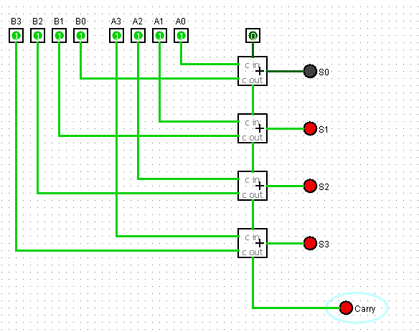

2) For the 4-bit Subtractor we use A0-A3 inputs, B0-B3 inputs, A control bit (M), 4 one bit Adders, 5 Xor Gates, 4 Diff LED’s for Output of the subtraction and an Overflow LED for the overflow. The control bit (M) , on Diagram it is set to 1, is connected to one of the C in pin of the One bit Adders and connected to each of the Exclusive Or (2 pin) Gates. The control bit M, is set to 1 to make the 2s complement of the input B0-B3 we need for the subtraction, if this control bit is set to 0 the circuit will work as a 4 bit adder. The input B0-B3 is connected to the other pin of the Exclusive Or (2 pin) Gate. The output of the Exclusive Or gate is connected to one of the Adder’s input pin. The inputs A0-A4 is connected to the other Adder’s input pin. The Adder’s C out is connected to the other Adder’s C in pins, hence that is how the Adders are linked together. The last Exclusive Or (2 pin) gate is used for overflow and is connected from the 3rd and 4th Adder’s C out pins. Each Adders are connected to an output, labelled as diff0-diff3 LEDs. If All the inputs A0-A3 and B0-B3 is set to 1. As the control bit is set 1, the B0-B3 values will have a 2s complement, hence none of the LED will light up since 1111 – 1111 = 0000. Similarly if we give input A0-A3 as 1101 (13) , and B0-B3 as 1010 (10), therefore 13 – 10 = 3, therefore the results should show 0011 (3) hence, diff0 and diff1 output LEDs will light up.

3) For the BCD Adder, to convert the binary adder to BCD adder we will need ,C + S3.S2 +S3.S1.

We will need a 4-bit Adder, like on the previous circuits, inputs A0-A3 and input B0-B3 will be connected to each Adders, and the adders will be connected together by the carry out pins and carry in pins of the Adder. Each of the Adders will have S0-S3 outputs. From the equation statement we see “C”, this is what the last C out of the Adder , and it needs to be connected with the rest of the Sum, which we will use , as we can see “+”, we will need an Or Gate (3 pin), The S3 sum output needs to be connected with S2 sum output via a And gate (2 pin) , similarly S3 sum output also have to have a connection between S1 sum output ,which again we have to use another And Gate (2 pin) . The output of both the And Gates needs to be connected to the inputs of the OR gate (3 pin) along with the C out of the Adder. The sum output S0-S3, needs to connect to another 4-bit Adder, they will occupy the first input of the other 4-bit adder on a similar way. This Adder is used when the output would be greater than 9, the Sum of the 2nd Adder will be the BCD Sum. When the 3 pin OR gate will have a value 1, it will pass that value to the 2nd 4 bit Adder , which will give us the BCD Sum.